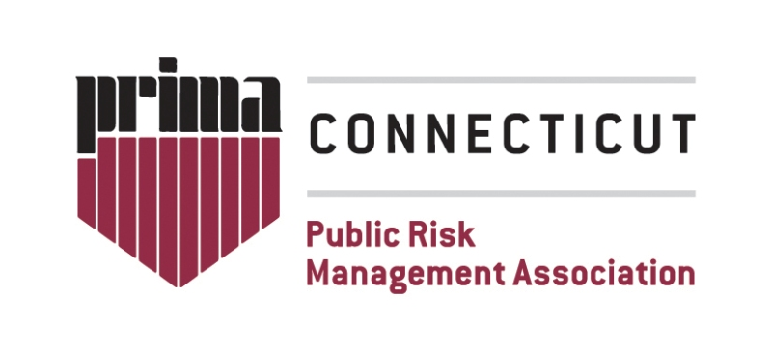
Connecticut PRIMA Business Meeting Minutes

Wednesday, Nov. 19, 2025
PMA Office, Glastonbury, CT

Thank you to Naomi Garcia from ServePro for sponsoring our lunch.
Thank you to PMA Companies for hosting our meeting and delivering today’s training.

Meeting called to order at 12:22 by Eve

- Approve minutes from Sept. 17, 2025 as posted on the website.
  - Megan 1st to approve
  - Kurt 2nd to approve

- Old business:
  - Our chapter awarded a scholarship to assist Megan with expenses related to her presentation at Prima Institute in Columbus, OH.

- New business:
  - The next PRIMA Institute session in Oct 19-23, 2026 in Alexandria, VA.
  - National PRIMA Conference is June 7-1, 2026 in Ft. Lauderdale, FL.
  - CT PRIMA has scholarships available for both events. Information and applications are on our website.
  - ARM (Associate in Risk Management) – Survey will be sent to members to gauge interest in organizing an ARM study group. Scholarships are available for this too. Please respond to the survey.

- Future meetings: topics and locations TBD
- Jan 14, 2026
- RM Week – April 20-24, 2026

- Meeting called to close at 12:38 PM
  - Kurt 1st to approve
  - Megan 2nd to approve

Minutes recorded by: Sara Lowenthal, Secretary

