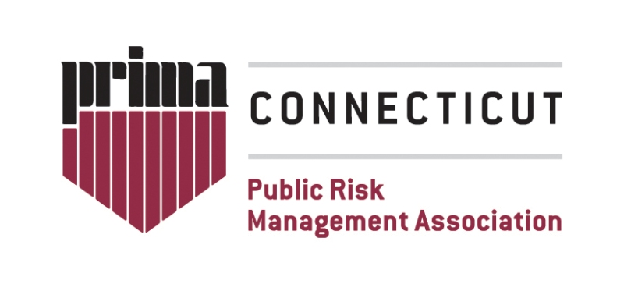
Scholarship Benefits: Scholarship recipient receives financial assistance in the amount equal to the registration fee to be applied to the registration and/or travel to one of PRIMA’s National events. Scholarships are on a first come basis and limited to one per person annually.
Applicants will be judged based on the following criteria:
- Years of public sector risk management experience
- Is an employee or official of a public entity; or an active retired member from a public entity
- Previous attendance at PRIMA’s Annual Conference
- Travel/Budget Restrictions
- Has direct or indirect responsibility for the risk management and/or insurance function for the organization.

Application Procedure: Applicants must complete the Application Form on page 2. The application must include all supporting documentation.

You are highly encouraged to electronically submit your application packet to info@ctprima.org

Application Contact Information
Please type or print

Name of Applicant:
Title:
Organization:
Current mailing address:
City, State and Zip Code:
Phone Number:
Email:

How many years of public sector risk management experience do you have?
1-5 years 6-10 years 11-15 years 16-20 years 21-25 years 25 or more years

Have you attended a PRIMA National Event in the past? Yes No
If yes, what was the last year you attended? _________________________

On a separate sheet of paper, please answer following questions.

1. Please provide a brief statement of financial need.

2. In 500 words or less, please state your expectations, purpose and goals in attending a PRIMA National Event:

If selected, I agree to attend PRIMA’s event named:_________________________________

Print Name: _____________________________________

Signature: ______________________________________ Date: ____________________

